**Lab - Create a Virtual Install of Metasploitable3 Using VirtualBox**

150182-Kipruto Isaac

Metasploitable3 is a VM of Windows Server 2008 made intentionally vulnerable.

Metasploitable3 is intended to be used as a target for testing exploits.

Metasploitable3 is a free virtual machine that allows you to simulate attacks essentially using Kali Linux and Metasploit.

Creating a VM of Metasploitable3 is as simple as having VirtualBox installed, downloading the OVA for Metasploitable3, and then x2 clicking the image to begin the importation process into VirtualBox.

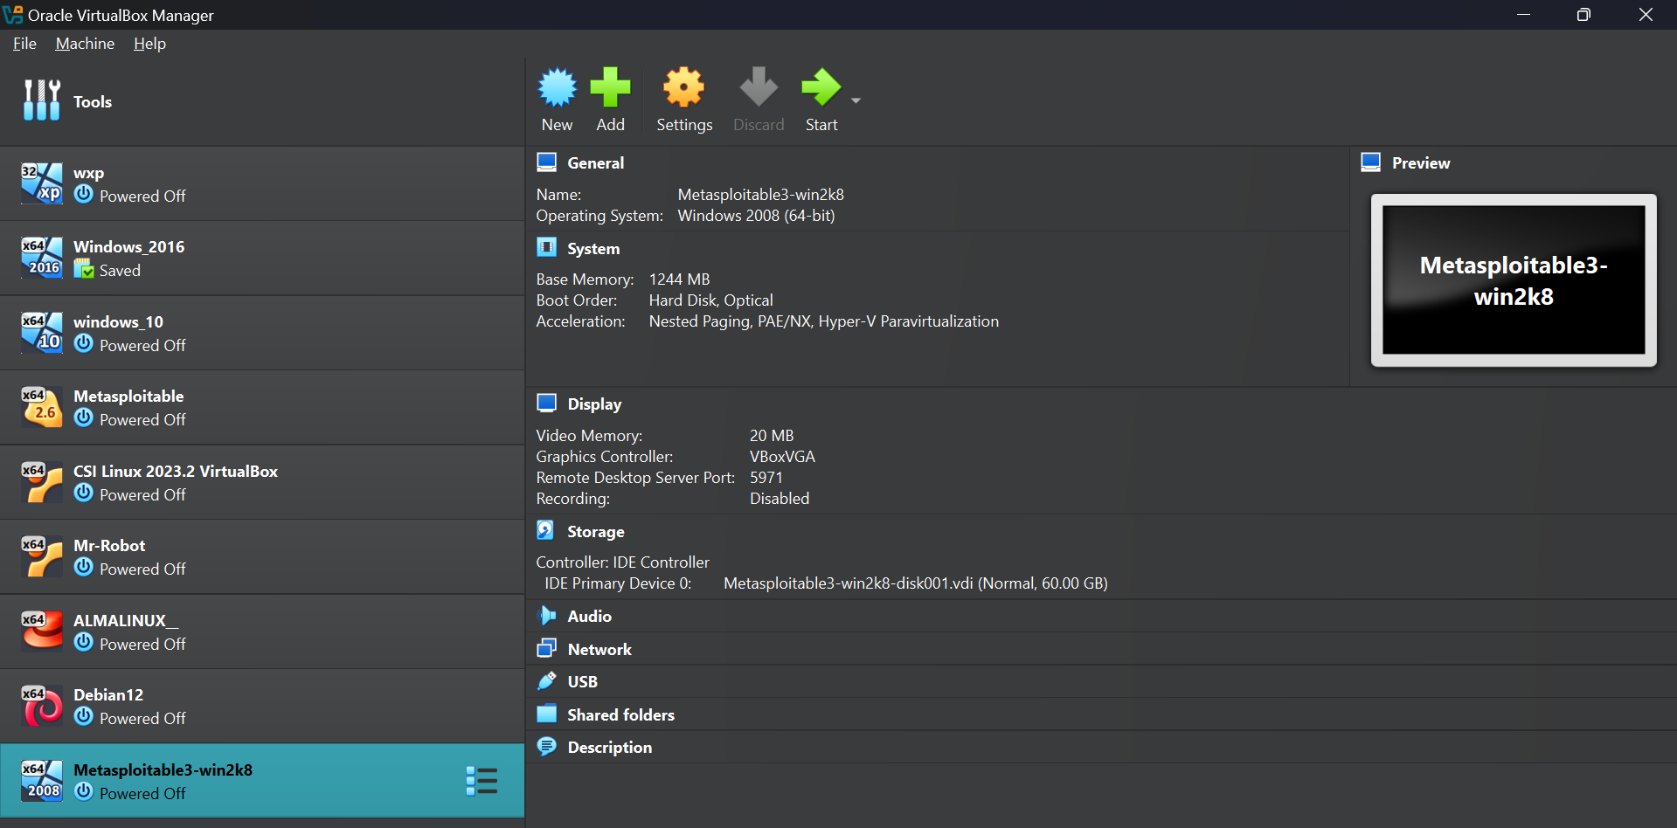

Change Host-only Adapter to NAT network adapter. Click OK.

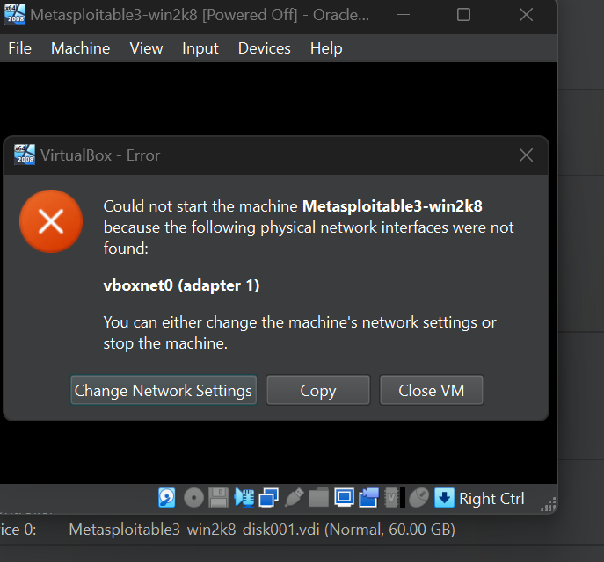

On the log-on screen, from the VirtualBox taskbar. Click on Input, and from the

content men, click on Keyboard, and from the next context button, select:

Insert Ctrl-Alt-Del.

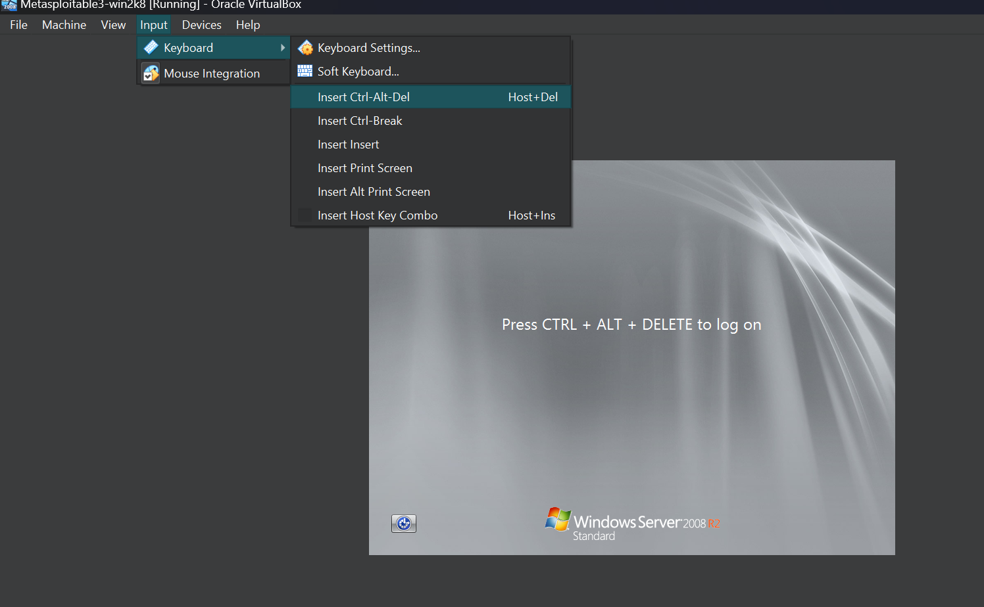

On the next screen, log on as the administrator.

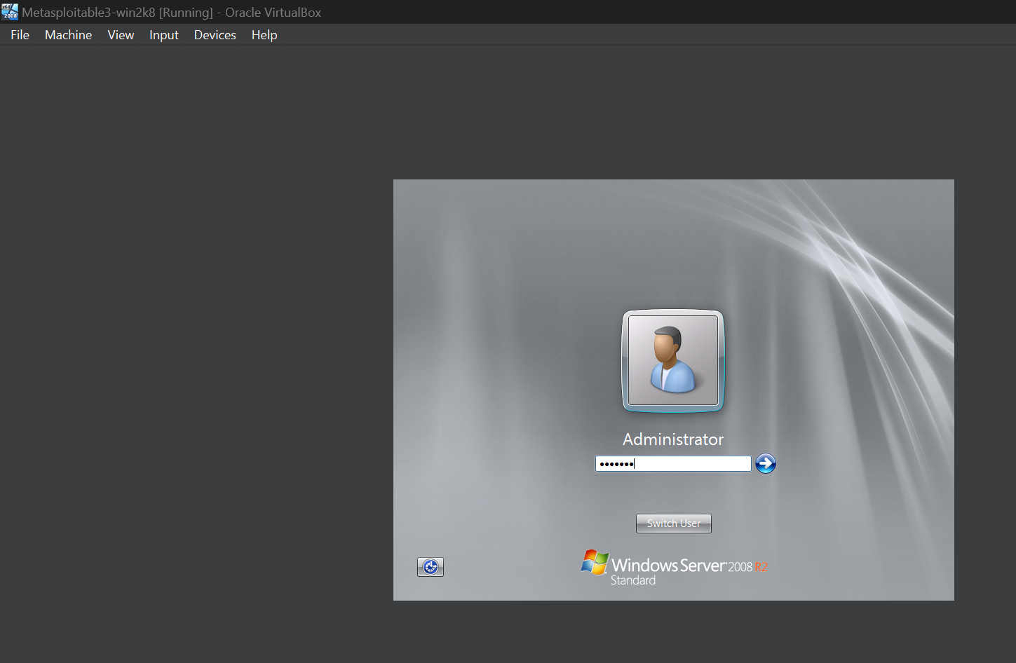

At the command prompt, type

slmgr /rearm

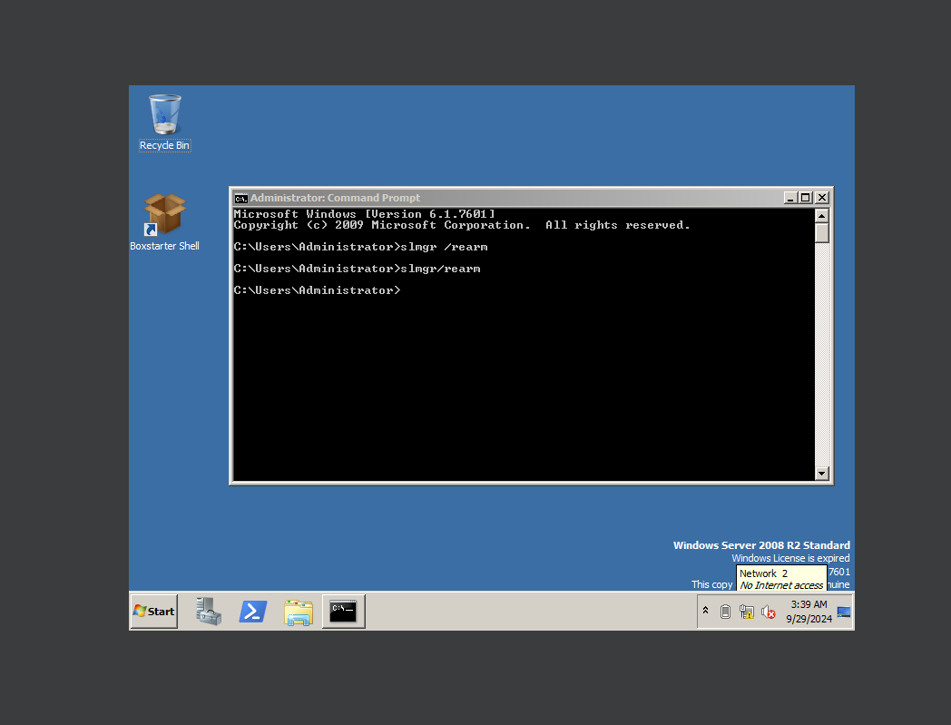

On the shutdown screen, type in some random characters and click OK.

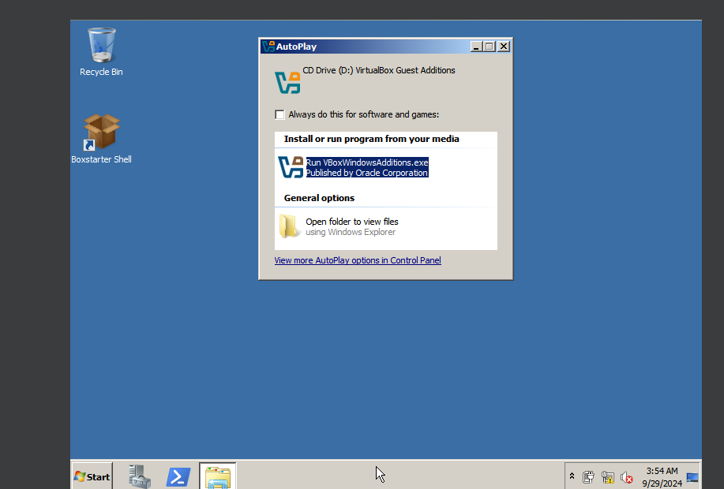

When the machine comes back up, log on as an administrator.

Once you have a desktop, from the VirtualBox taskbar, click on Devices and then

network setting.

Find your IP address

